IaaS, PaaS, and SaaS – Cloud Computing Models

# 1. Introduction

Cloud computing offers scalable and flexible IT services through the internet. The three primary models—Infrastructure as a Service (IaaS), Platform as a Service (PaaS), and Software as a Service (SaaS)—provide varying degrees of control, flexibility, and management. Each model supports different business needs, enabling efficient resource use, cost reduction, and simplified operations.

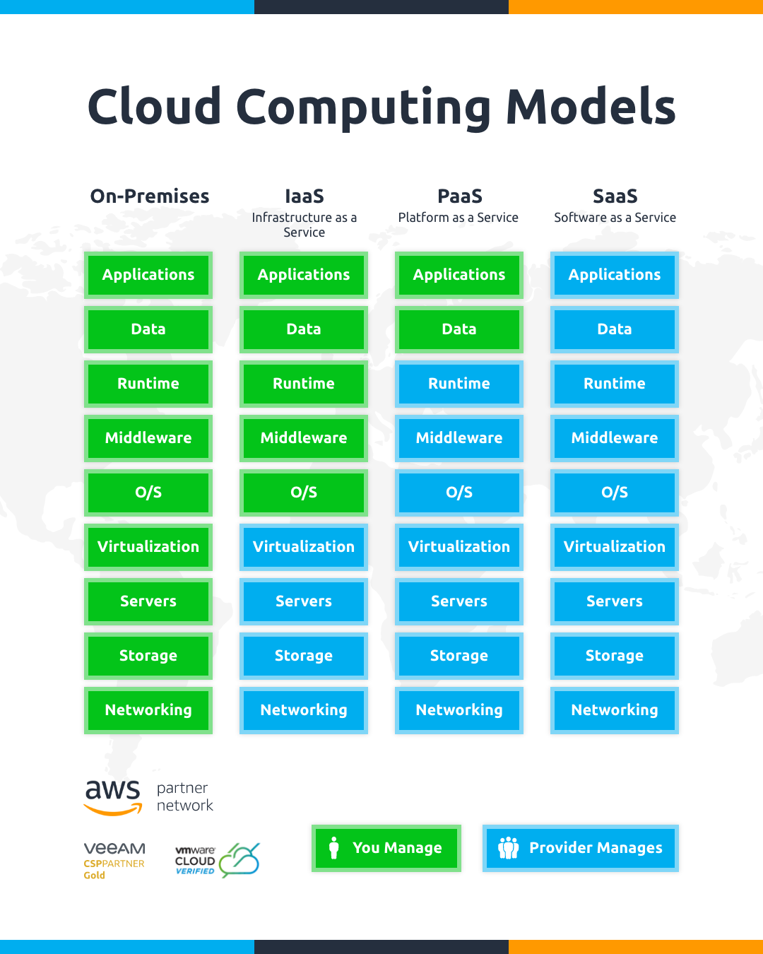

# 2. Infrastructure as a Service (IaaS)

IaaS provides basic computing infrastructure—virtual servers, storage, and networks—on demand. Users can install and manage their own OS, middleware, and applications. The cloud provider manages the physical infrastructure. IaaS is ideal for system administrators and developers who need a customizable environment.

Examples: Amazon EC2, Google Compute Engine, Microsoft Azure VMs

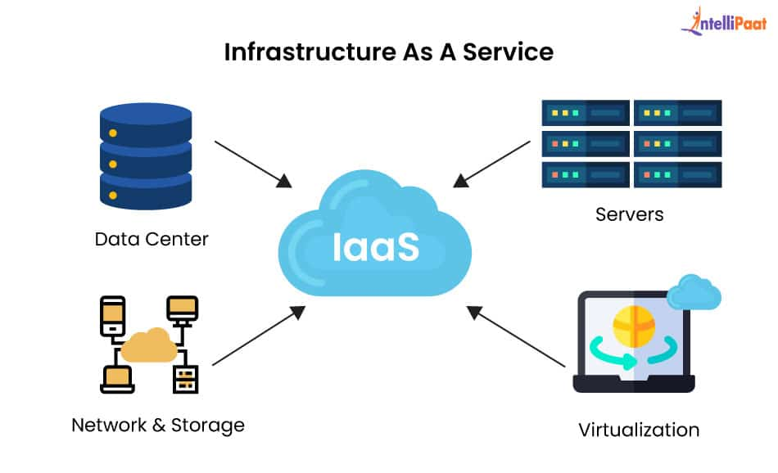

# 3. Platform as a Service (PaaS)

PaaS offers a platform allowing developers to build, deploy, and manage applications without dealing with infrastructure complexity. The provider handles servers, storage, and networking, freeing users to focus on development and deployment. PaaS also supports continuous integration and scalability.

Examples: Google App Engine, Heroku, Microsoft Azure App Services

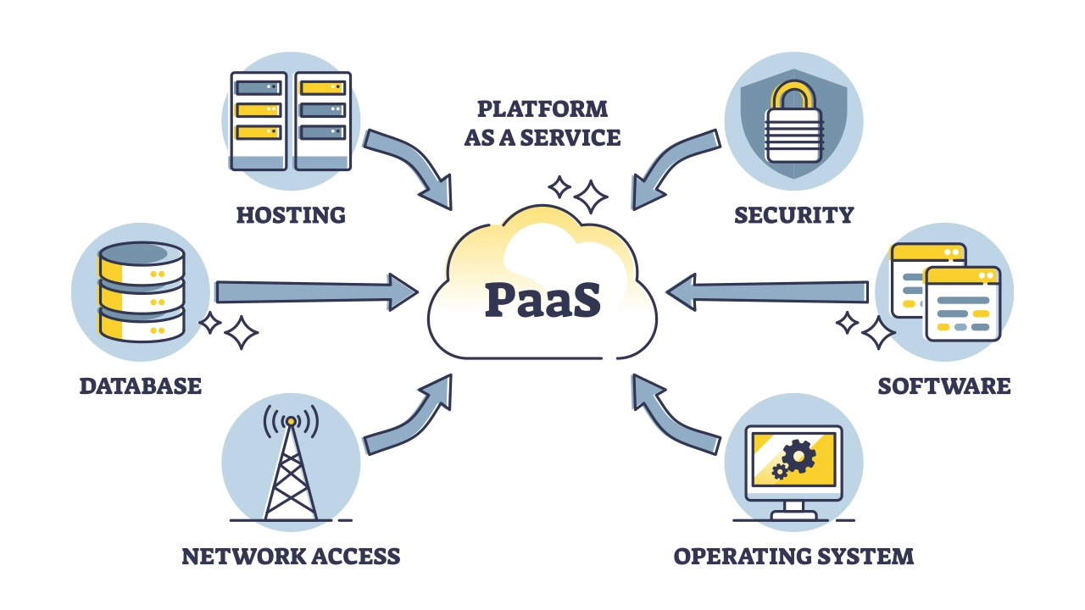

# 4. Software as a Service (SaaS)

SaaS delivers ready-to-use software applications over the internet. Users access these applications via browsers without installing or maintaining anything. The provider manages all aspects including infrastructure, updates, and security. SaaS is suitable for end-users needing simple, scalable software solutions.

Examples: Microsoft 365, Google Workspace, Zoom

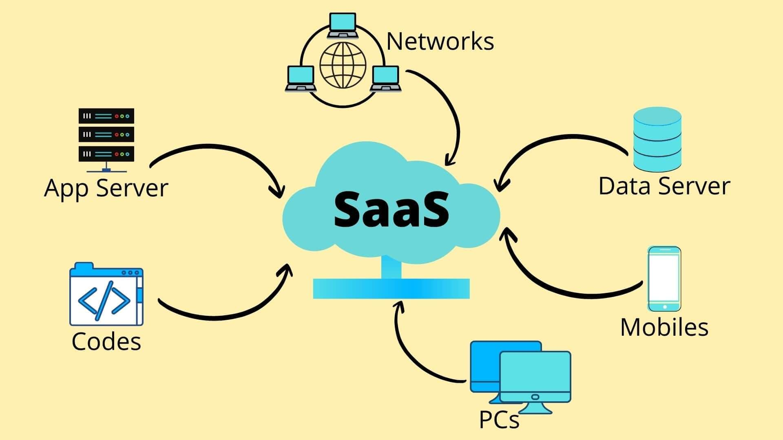

# 5. Comparison Table

|  |  |  |  |
| --- | --- | --- | --- |
| Feature | IaaS | PaaS | SaaS |
| User Control | OS, Apps, Data | Apps, Data | Minimal |
| Maintenance | User | Shared | Provider |
| Use Case | Custom Environments | App Development | End-User Apps |
| Examples | AWS EC2, Azure VMs | App Engine, Heroku | Zoom, Google Workspace |

# 6. Real-world Analogy

- IaaS: Renting an empty lot and building your house.  
- PaaS: Renting a furnished apartment—you bring your lifestyle.  
- SaaS: Booking a hotel room—everything is ready for use.

# 7. Pros and Cons

IaaS Pros:  
- High control and flexibility  
- Scalable and cost-effective

IaaS Cons:  
- Requires technical management  
- User responsible for security

PaaS Pros:  
- Faster development  
- No infrastructure management

PaaS Cons:  
- Limited control  
- Potential vendor lock-in

SaaS Pros:  
- Easy to use  
- Fully managed by provider

SaaS Cons:  
- Limited customization  
- Data dependency on provider

# 8. Conclusion

Choosing the right cloud service model depends on the level of control and responsibility your organization requires. IaaS is perfect for customizability, PaaS speeds up development, and SaaS offers ready-to-use solutions. Understanding these models helps in making informed decisions that align with business goals.